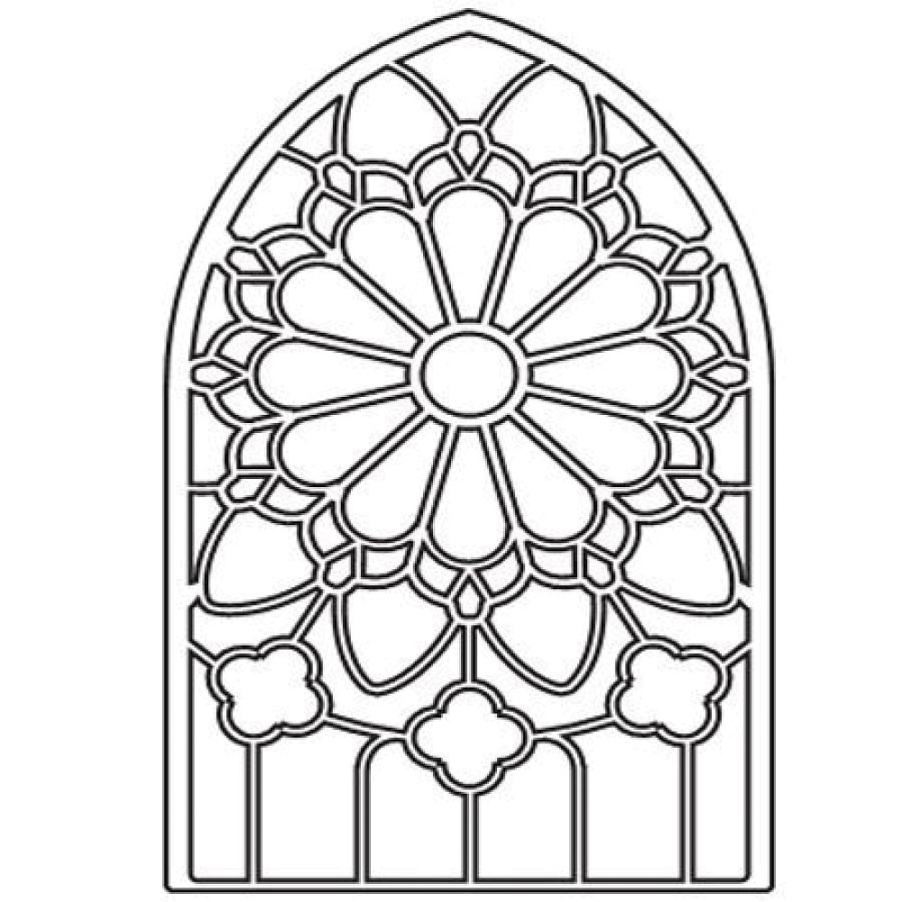

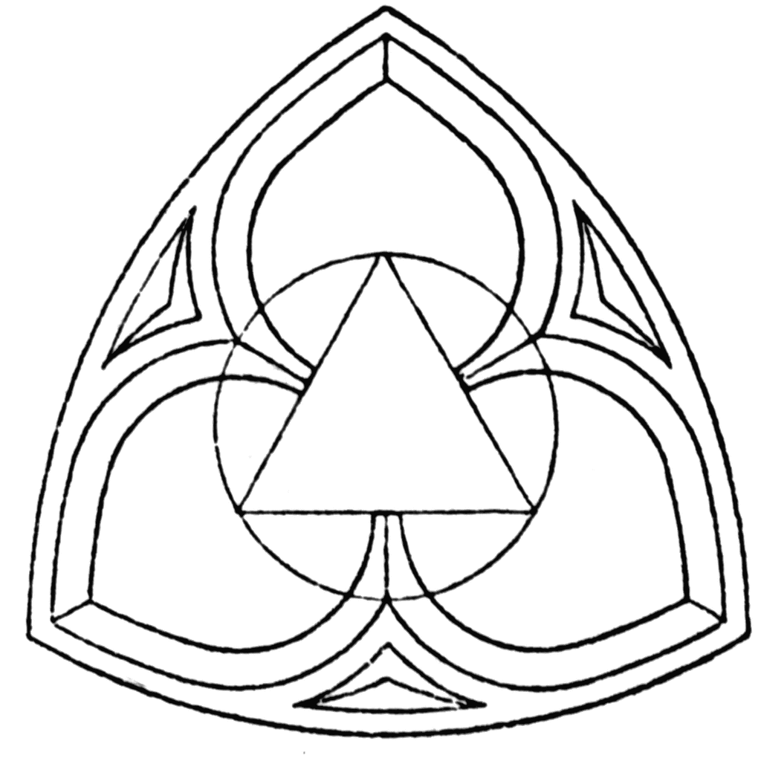

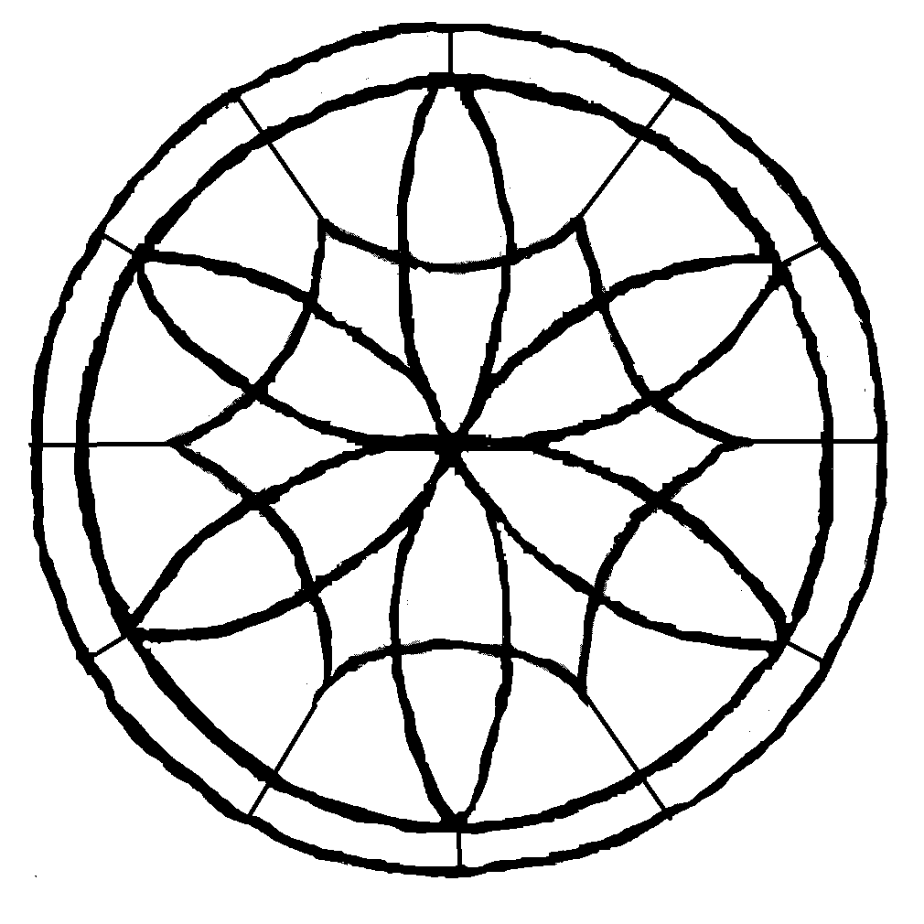



[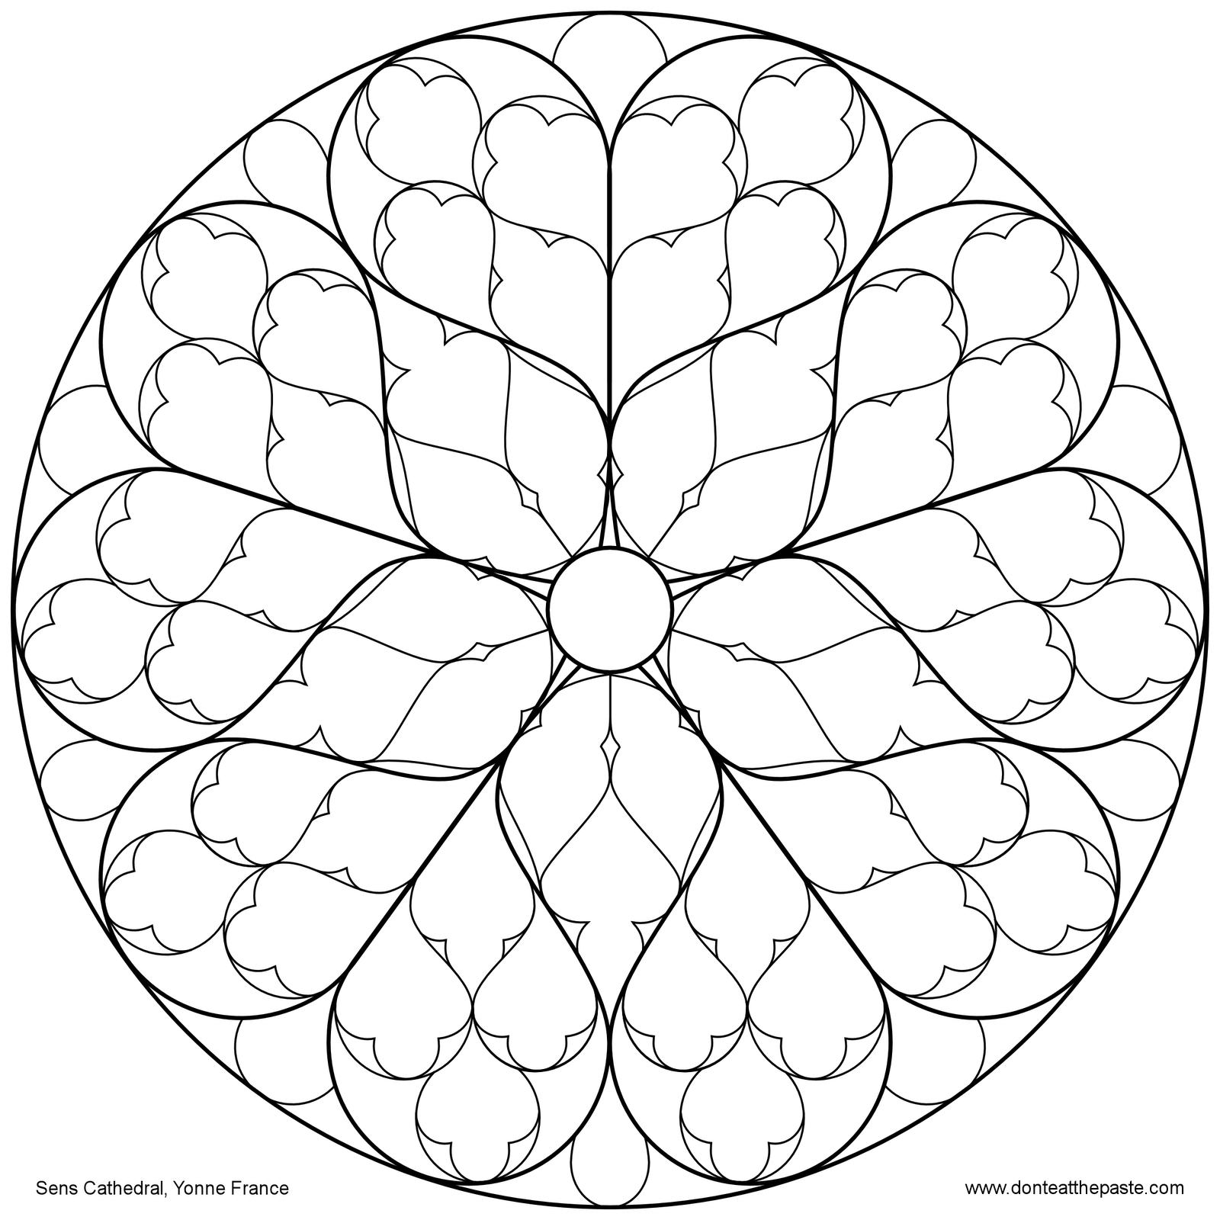](about:blank)

[